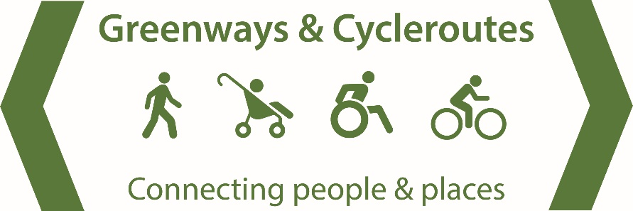
We build new walking and cycling routes by helping local supporters groups to:  - Decide on the best route and get planning consent  - Negotiate with landowners  - Seek grant funding  - Organising work camps  - Establishing maintenance programmes |  | 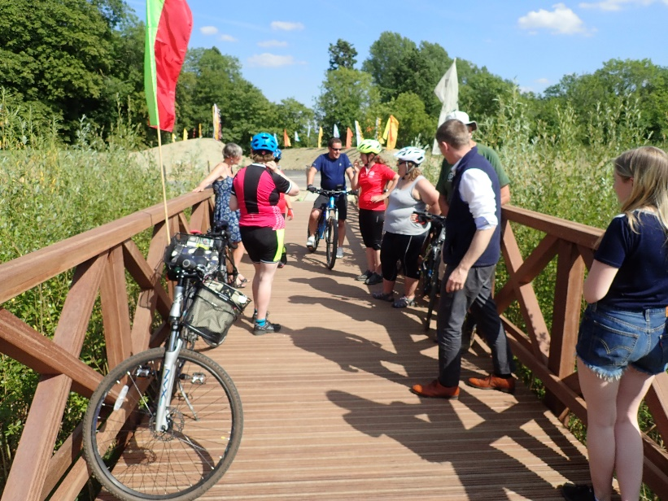

For more information email greenwaysandcycleroutes@gmail.com
www.greenwaysandcycleroutes.org

Supporters’ application form

We rely on supporters’ annual membership, and welcome donations

Name …………………………………………………………………………………..…… |  | I enclose £ ………………………………………………………….
House number …………………….. Post code ……………………………..….. |  | Signed …………………………………….…………..................
Email address ……………………………………………………………….………………………………………………………………….…..…………………….

Membership is £10 a year, or whatever you can afford.  Pay by cheque with this form or electronically to:  co-operative bank a/c 6578 8600 sort code 08-92-99 |  | Please send cheque payable to ‘Greenways and Cycleroutes Limited’ to: Caroline Levett  39 Cornwallis Crescent  Bristol BS8 4PH
Developing and maintenance of all routes projects
Brean Down Way  Weston and Brean | Wye Valley Greenway | Waddesdon Parkway  Aylesbury and Waddesdon
I am a UK taxpayer. Please reclaim tax on all my donations to Greenways and Cycleroutes Limited until I notify you otherwise. I understand that I must pay enough income or capital gains tax to cover the amount Greenways will be reclaiming.
Greenways and Cycleroutes Limited is a Community Benefit Society, regulated by the Financial Conduct Authority, Mutuals Public Register 7273 CB

